R.K.SUSHMITHA 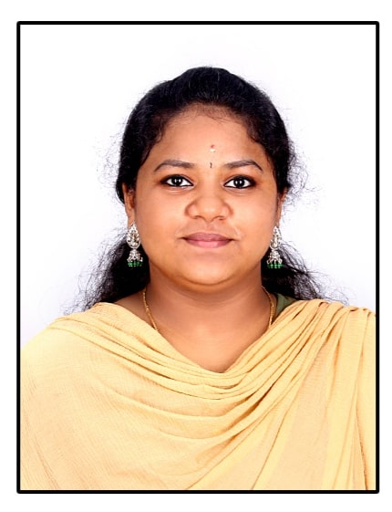
No.555 Quidth millath nagar
11th street villar road
Thanjavur-613006
E-mail Id : rksushmitha16@gmail.com
Mobile no : +91 9865721227

OBJECTIVE
To build career in a growing organization, where I can get the opportunities to prove my abilities by accepting challenges, fulfilling the organizational goal and climb the career ladder through continuous learning and commitment.

ACADAMIC QUALIFICATION

COURSE | NAME OF THE INSTITUTION | UNIVERSITY/  BOARD | PERCENTAGE | DURATION
B.E. (ECE) | K. Ramakrishnan College of Engineering,  Trichy | Autonomous | 8.6* | 2019-2023
HSC | St. Joseph’s Girls Higher Secondary School,  Thanjavur | State Board | 62.4% | 2018-2019
SSLC | St. Joseph’s Girls Higher Secondary School,  Thanjavur | State Board | 89% | 2016-2017

*CGPA up to IV Semester

AREA OF INTEREST

- Digital Electronics

TECHNICAL PROFILE

- LANGUAGES : Python

PAPER PRESENTATION

- Presented a paper on “Computer Forensics” in K. Ramakrishnan College Of Engineering,Trichy
- Presented a paper on “Artificial Intelligence” in SRM TRP Engineering College,Trichy
- Presented a paper on “Brain Of Computing” in K. Ramakrishnan College Of Engineering,Trichy

PROJECT

- Exibited a mini project on “Fire sensor” in inter college Expo

ACHIEVEMENTS

- Won Overall championship in Symposium at SRM TRP Engineering College, Trichy
- Won championship in hockey in 2017
- Won 1st place in karate competition in school days

CO – CURRICULAR ACTIVITIES

- Certified in BA Hindi
- Acted as a member of NSS(National Service Scheme)
- Learned Japanese language (beginner level)

PERSONAL STRENGTH

- Fast learner and easily adopted in new working place

PERSONAL PROFILE

Father’s Name : Mr. R. Rajendran
Gender : Female
Date of Birth : 16-03-2002
Nationality : Indian
Languages Known : Tamil, English,Hindi, Japanese (to read, to write, to speak)
Hobbies : Photography, Voracious reader

Place:
Date:
(R.K.SUSHMITHA)

